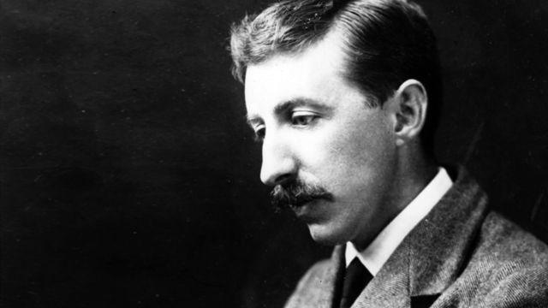**E.M. Forster (1879-1970)**

One of the leading British novelists of the early decades of the twentieth century, Edward Morgan Forster is best known for his novels *Howards End* (1910) and *A Passage to India* (1924). Forster attended Cambridge University where he became a member of the Cambridge Apostles secret society, which brought him into contact with the Bloomsbury Group, including economist James Maynard Keynes and biographer Lytton Strachey. Forster’s work is best remembered for its use of Realism to denounce the repressiveness of Edwardian British culture, and is often infused with Forster’s liberal humanism. Forster was highly influenced by his travels throughout the European continent and India, and his works often illustrate this interest by focusing on settings outside of England. All of the novels published in Forster’s lifetime were published before 1925, after which Forster spent his life working on non-fiction, including biographies, travel narratives, and essays.

Forster was born 1 January 1879 into a respectable London family. His father died of consumption in 1880, leaving Forster’s childhood dominated by female figures. After an inheritance allowed Forster a successful childhood education, he obtained bachelor’s degrees in Classics (1900) and History (1901) from Cambridge. Following his graduation, Forster travelled with his mother in Greece and Italy from 1901 to 1907, before returning home to England to lecture at Working Men’s College, London. These travels would influence Forster’s writing – both fiction and non-fiction – as would his service as a Red Cross Volunteer in Alexandria, Egypt and his later trips to India in 1912 and 1921. Forster returned to England in 1921 and remained there until his death in 1970.

Forster’s first novel, *Where Angels Fear to Tread* (1905), shows the influence of Forster’s early travels. Lilia Herriton and her daughter Irma travel to Italy, where Lilia falls in love with an Italian peasant named Carella. After being disowned by the Herriton family and realizing her marriage with Carella isn’t what she thought it was, Lilia dies giving birth to Carella’s son. The Herriton family desires to bring the new child back to England and sends Philip Herriton, Lilia’s brother-in-law, to retrieve the child. The baby is killed in an accident before the Herritons reconcile with Carella and return to England.

Forster’s next novel, *The Longest Journey* (1907), was his first major work. This novel, a sort of bildungsroman, takes place in England and is set primarily in Cambridge and Wiltshire. The novel follows the lives of the disabled Rickie Elliot and his half-brother Stephen Wonham. The novel focuses primarily on Rickie’s progression and developing relationship with his half-brother. The novel ends with Rickie’s death while saving Stephen from a train.

His third novel, *A Room with a View* (1908), also emphasizes Forster’s early travels to the continent. This novel focuses on the interactions between the bourgeois family of Lucy Honeychurch and the more progressive family of George Emerson. This novel anticipates the later class analysis in *Howards End*, and illustrates the class conflicts that were common in the early years of the twentieth-century. In the end of the novel, Lucy turns away from wealthier Cecil Vyse and marries the working-class George Emerson. *Howards End* (1910) gives a more complete view of the social and economic relationships in turn-of-the-century England. The novel follows the Schlegel sisters (Helen and Margaret) and their interactions with the wealthy Wilcox family and the poor Bast family.

The last novel published during Forster’s life, *A Passage to India* (1924), is often considered to be hi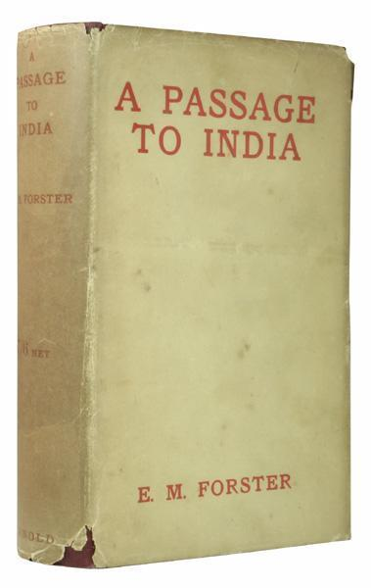s masterpiece. After traveling to India, Forster set the novel against the Indian Independence movement. It is loosely based on his own experiences. The novel centers on the young Englishwoman Adela Quested’s journey to India to meet Ronny Heaslop, a colonial officer she may marry. In an effort to experience the authentic India, Adela and Ronny’s mother Mrs. Moore visit the Marabar caves with Dr. Aziz, a local physician. Adela accuses Dr. Aziz of sexual assault and a trial ensues. During the trial Adela recants her accusation and Aziz is freed. Critics have celebrated the novel as a detailed examination of the British colonial system and an unmasking of the civilizing mission associated with the British Empire.

After the publication of *A Passage to India,* Forster began to focus his creative attentions on non-fiction, including biographies and historical accounts. His last novel, *Maurice* (1971), would not be published until after Forster’s death. This novel, suppressed because of its homosexual content, follows the coming-of-age story of Maurice Hall and his conflicted feelings about his homosexuality.

Although Forster did not publish a novel in the last four decades of his life, his reputation as a novelist persists. His work *Howards End* remains celebrated for its depiction of the social and economic systems of early-twentieth century England, while *A Passage to India* stands as a canonical English text of the early twentieth century and remains an important indictment of the British colonial system. Forster remains one of the most important and influential writers in twentieth-century British literature.

-Adam R. McKee

**Key Works During Lifetime:**

*Where Angels Fear to Tread* (1905)

*The Longest Journey* (1907)

*A Room with a View* (1908)

*Howards End* (1910)

*A Passage to India* (1924)

**Published Posthumously**

*Maurice* (1971)

* FORSTER IMAGE URL <http://www.bbc.co.uk/iplayer/images/episode/b00n5vjs_640_360.jpg>